**Basic Electronic Lab**

Report Submitted By-

Md. Waliul Islam Rayhan

ID: B190305034

Course Code: CSEL-1206

Submitted to-

Lecturer Md. Tanvir Ahammad

Department of Computer Science & Engineering

Jagannath University

***Experiment No:******01***

**Experiment Name:** To verify Zener diode as a voltage regulator with fixed input voltage Vin and variable load resistance RL.

**Objective:** To study Zener diode as a voltage regulator, when input voltage Vin is fixed while load resistance RL is variable.

**Components:**

1. DC power supply +15V external source
2. Digital Multimeter (DMM)
3. Resistor (2 pcs)
4. Breadboard
5. Wires

**Circuit Diagram:** Circuit used to study Zener diode as a voltage regulator is shown in the following figure:

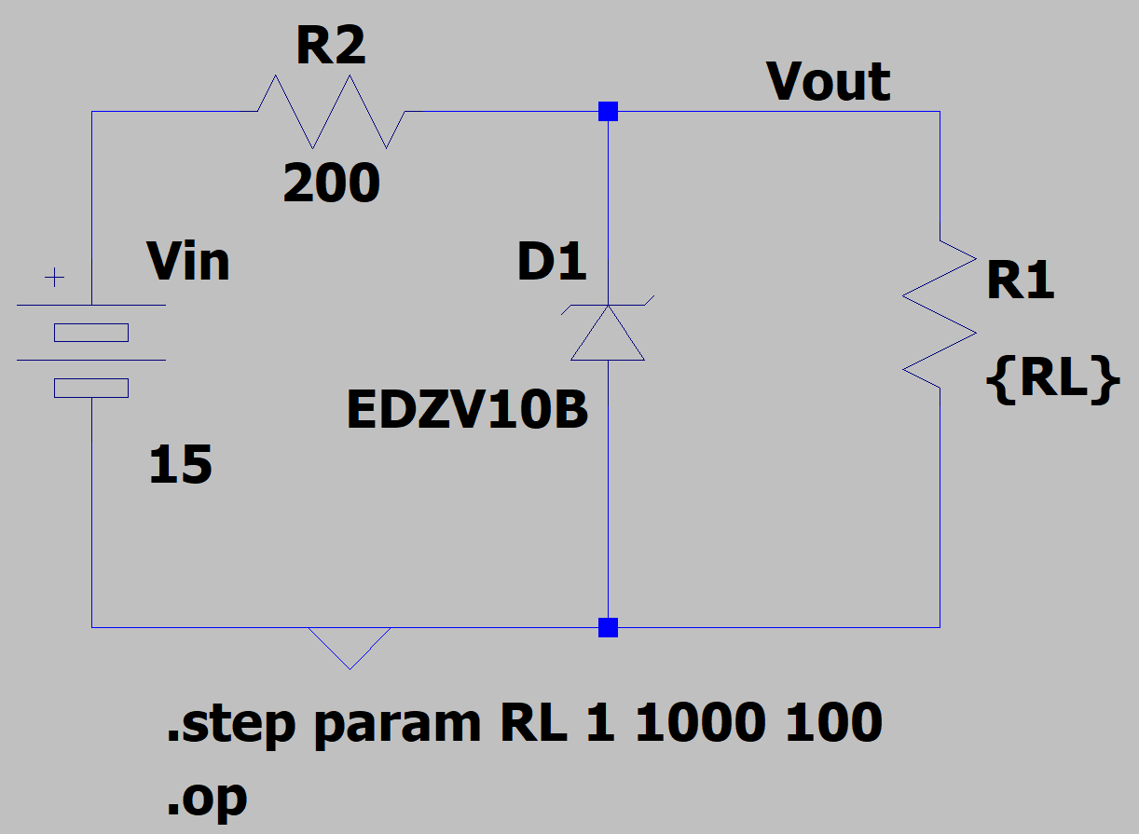

**Figure 1.1:** A Zener Diode Voltage Regulator

**Graph:**

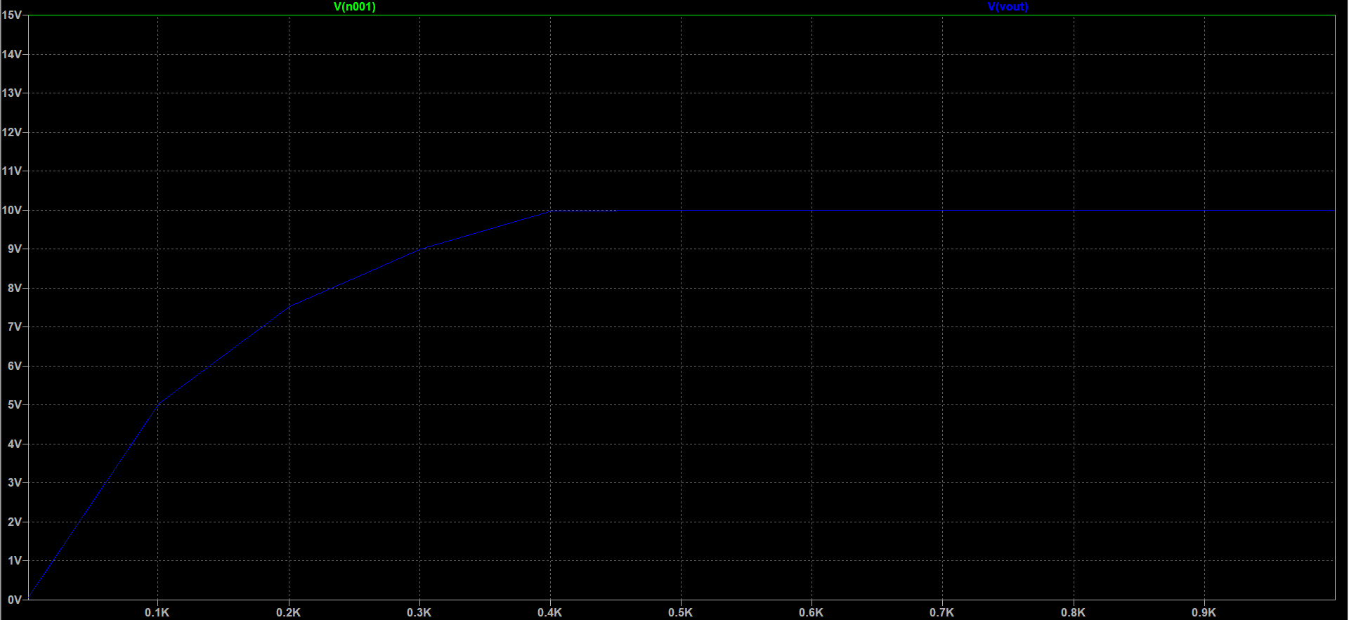

*\*Green line indicates input*

*\*Blue line indicates output*

**Graph 1.1:** Input and Output waveform of Zener Diode Voltage

***Experiment No:******02***

**Experiment Name:** To verify Zener diode as a voltage regulator with fixed load resistance RL and variable input voltage Vin.

**Objective:** To study Zener diode as a voltage regulator, when input voltage Vin is variable while Load resistance RL is fixed.

**Components:**

1. DC power supply + (1 — 30) V external source
2. Digital Multimeter (DMM)
3. Resistor (2 pcs)
4. Breadboard
5. Wires

**Circuit Diagram:** Circuit used to study Zener diode as a voltage regulator is shown in the following figure:

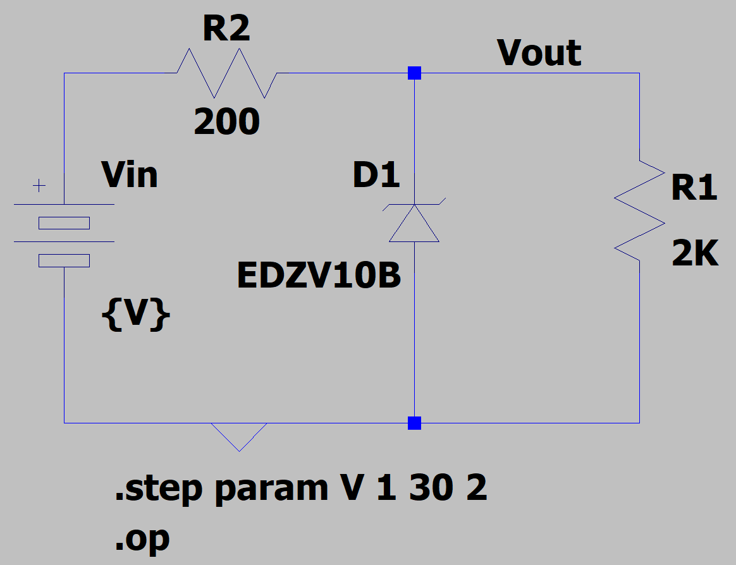

**Figure 2.1:** A Zener Diode Voltage Regulator

**Graph:**

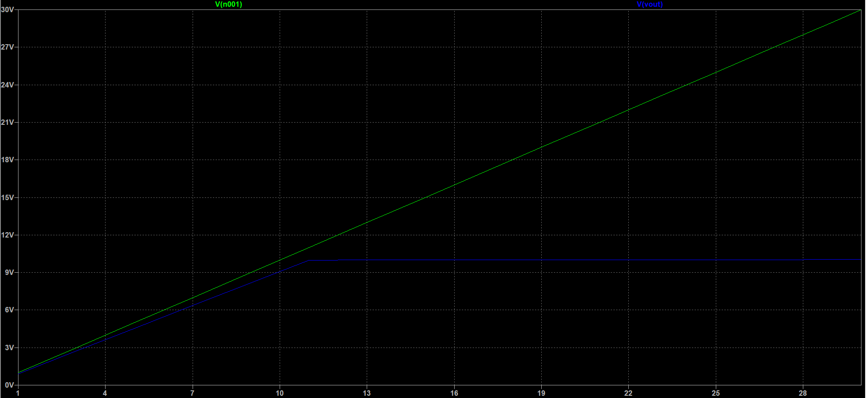

*\*Green line indicates input*

*\*Blue line indicates output*

**Graph 2.1:** Input and Output waveform of Zener Diode Voltage

***Experiment No:******03***

**Experiment Name:** To verify and experiment Half-wave and Full-wave rectifier.

**Objective:** To study the characteristics and operation of Half-wave and Full-wave rectifier.

**Components:**

1. DC power supply
2. Digital Multimeter (DMM)
3. Resistor (2 pcs)
4. Transformer
5. Breadboard
6. Diode (5 pcs)
7. Wires

**Circuit Diagram (Half-wave rectifier):** Circuit used to study Half-wave rectifier is shown in the following figure:

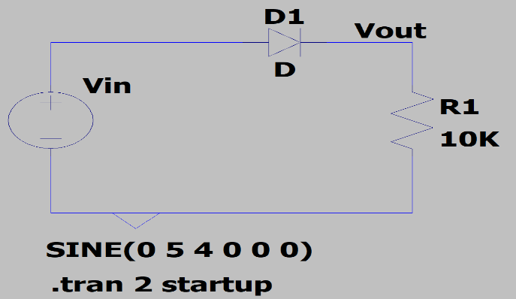

**Figure 3.1:** A Half-wave rectifier

**Graph (Half-wave rectifier):**

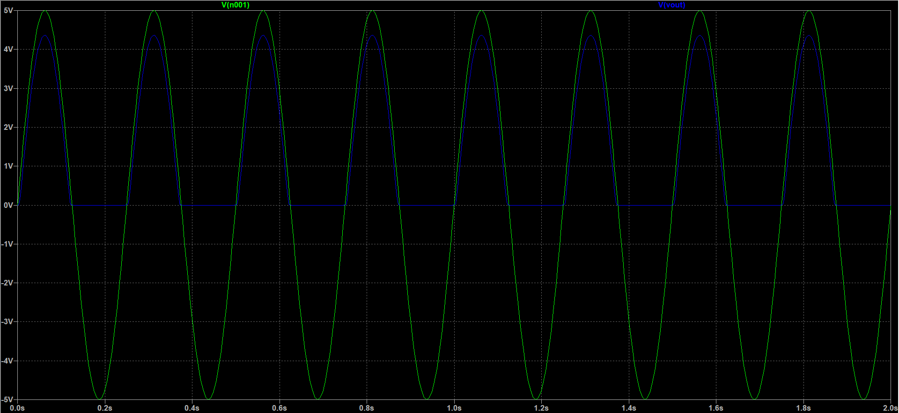

*\*Green line indicates input*

*\*Blue line indicates output*

**Graph 3.1:** Input and Output waveform of Half-wave rectifier

**Circuit Diagram (Full-wave rectifier):** Circuit used to study Full-wave rectifier is shown in the following figure:

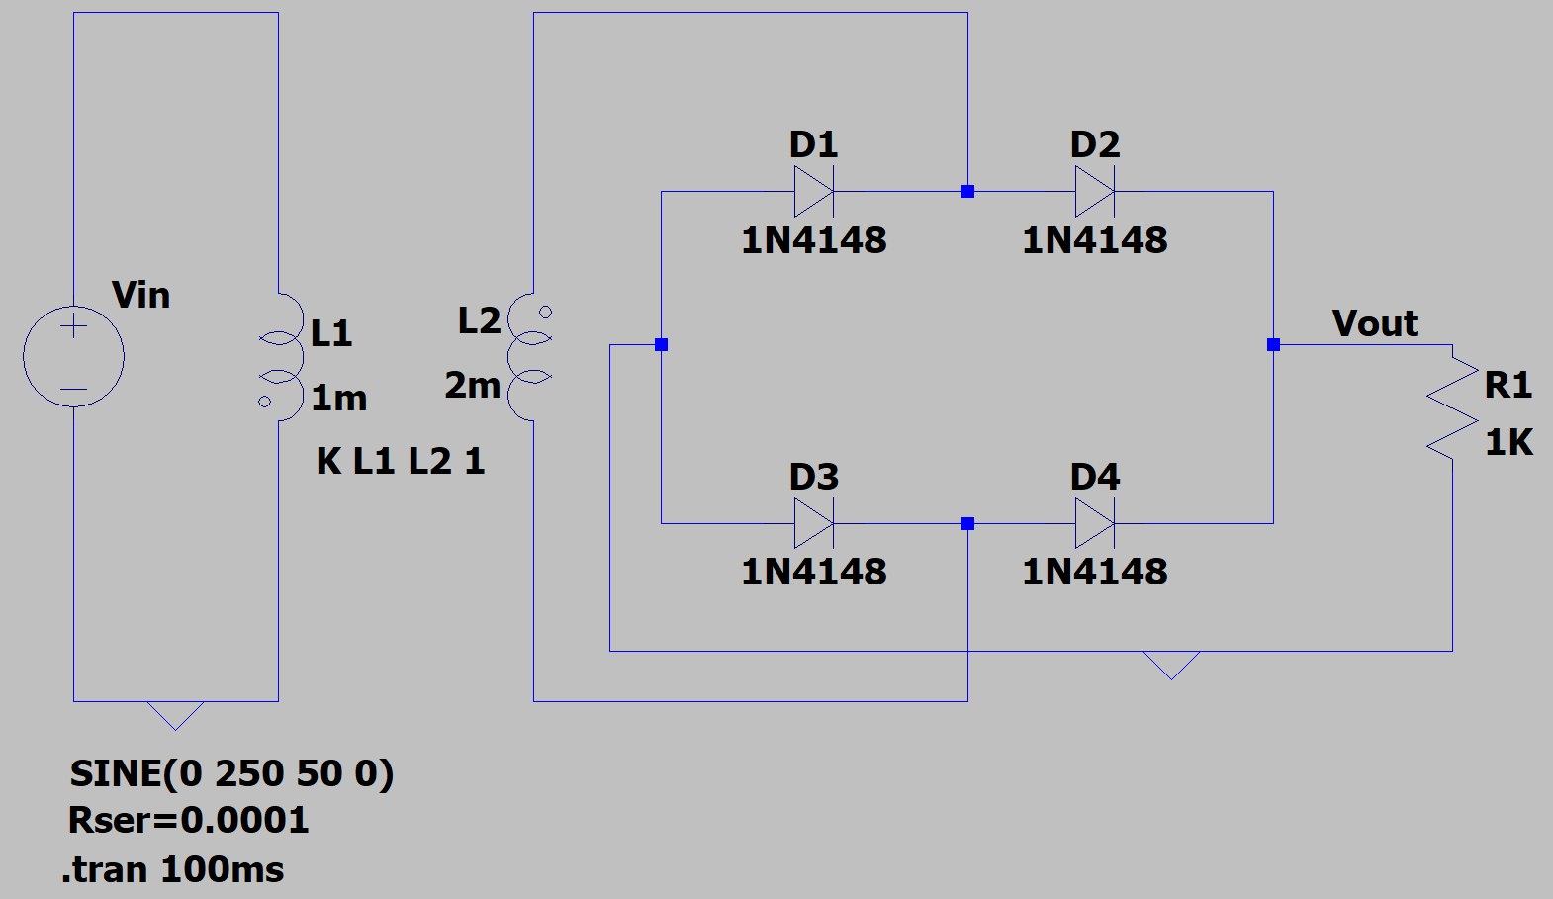

**Figure 3.2:** A Full-wave rectifier

**Graph (Full-wave rectifier):**

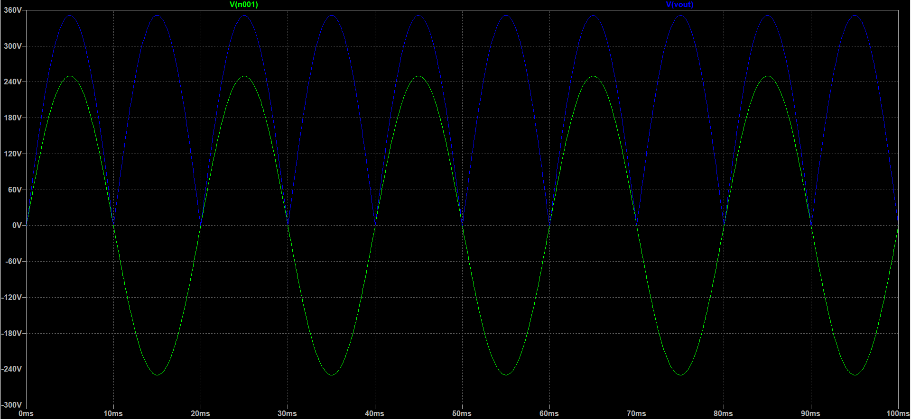

*\*Green line indicates input*

*\*Blue line indicates output*

**Graph 3.2:** Input and Output waveform of Full-wave rectifier

***Experiment No:******07***

**Experiment Name:** To design and verify Inverting and Non-inverting amplifier using 741 Op-amp.

**Objective:** To study the input & output waveform of Inverting and Non-inverting amplifier using 741 Op-amp.

**Components:**

1. DC power supply
2. Digital Multimeter (DMM)
3. Resistor (4 pcs)
4. IC — LM741 (2 pcs)
5. Breadboard
6. Wires

**Circuit Diagram (Inverting amplifier):** Circuit used to study Inverting amplifier is shown in the following figure:

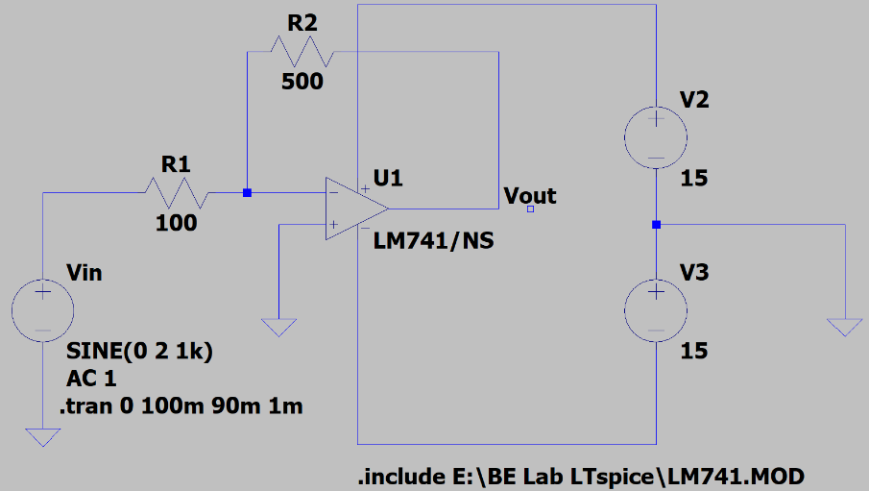

**Figure 7.1:** An Inverting amplifier using LM741

**Graph (Inverting amplifier):**

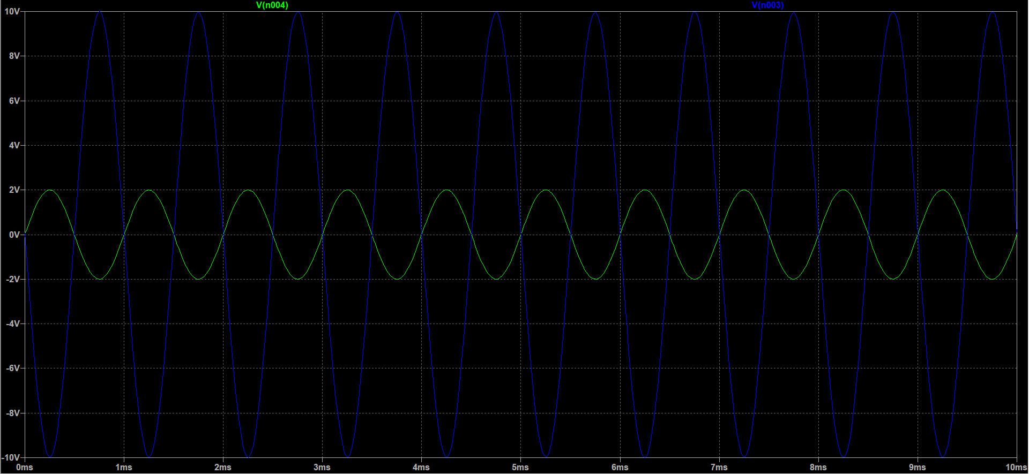

*\*Green line indicates input*

*\*Blue line indicates output*

**Graph 7.1:** Input and Output waveform of Inverting amplifier

**Circuit Diagram (Non-inverting amplifier):** Circuit used to study non-inverting amplifier is

shown in the following figure:

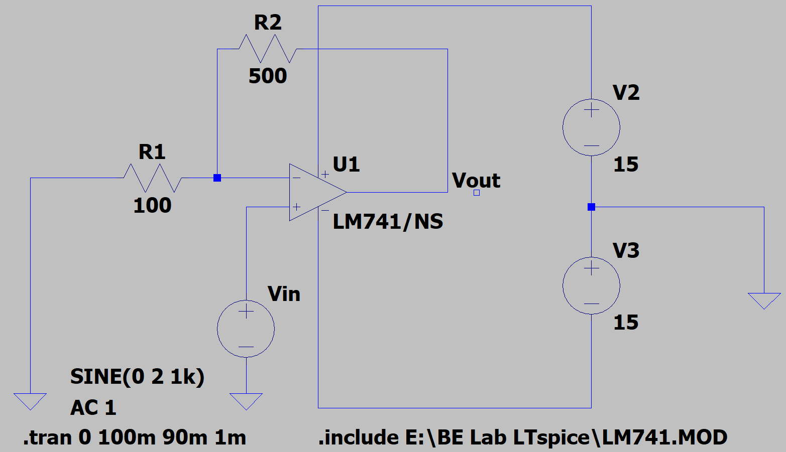

**Figure 7.2:** A Non-inverting amplifier using LM741

**Graph (Non-inverting amplifier):**

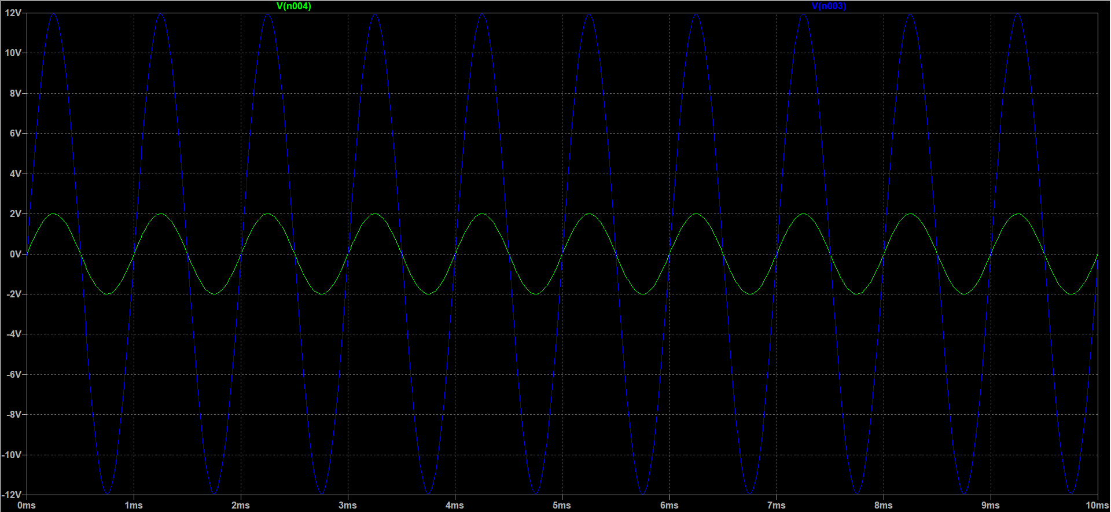

*\*Green line indicates input*

*\*Blue line indicates output*

**Graph 7.2:** Input and Output waveform of non-inverting amplifier

***Experiment No:******08***

**Experiment Name:** To design and verify the operations of Summing and Subtractor amplifier circuit using 741 Op-amp.

**Objective:** To study the input & output waveform of Summing and Subtractor amplifier circuit using 741 Op-amp.

**Components:**

1. DC power supply
2. Digital Multimeter (DMM)
3. Resistor (9 pcs)
4. IC — 741 Op-amp (2 pcs)
5. Breadboard
6. Wires

**Circuit Diagram (Summing amplifier):** Circuit used to study Summing amplifier is shown in the following figure:

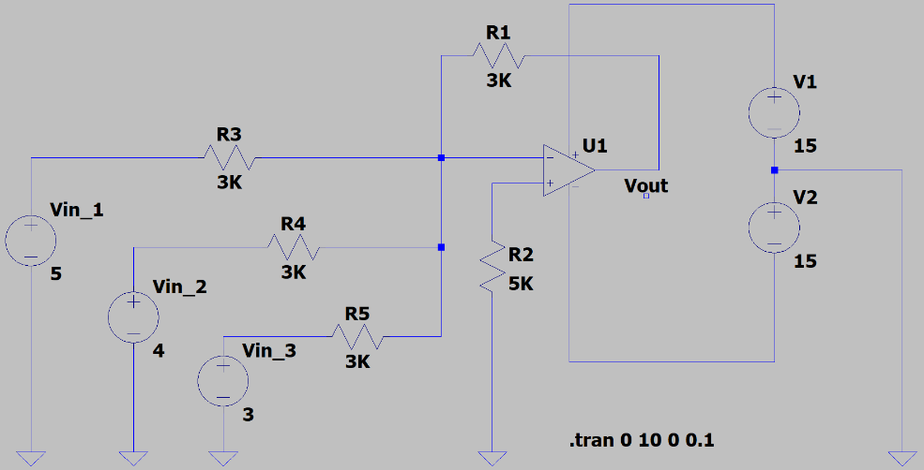

**Figure 8.1:** A Summing amplifier using 741 Op-amp

**Graph (Summing amplifier):**

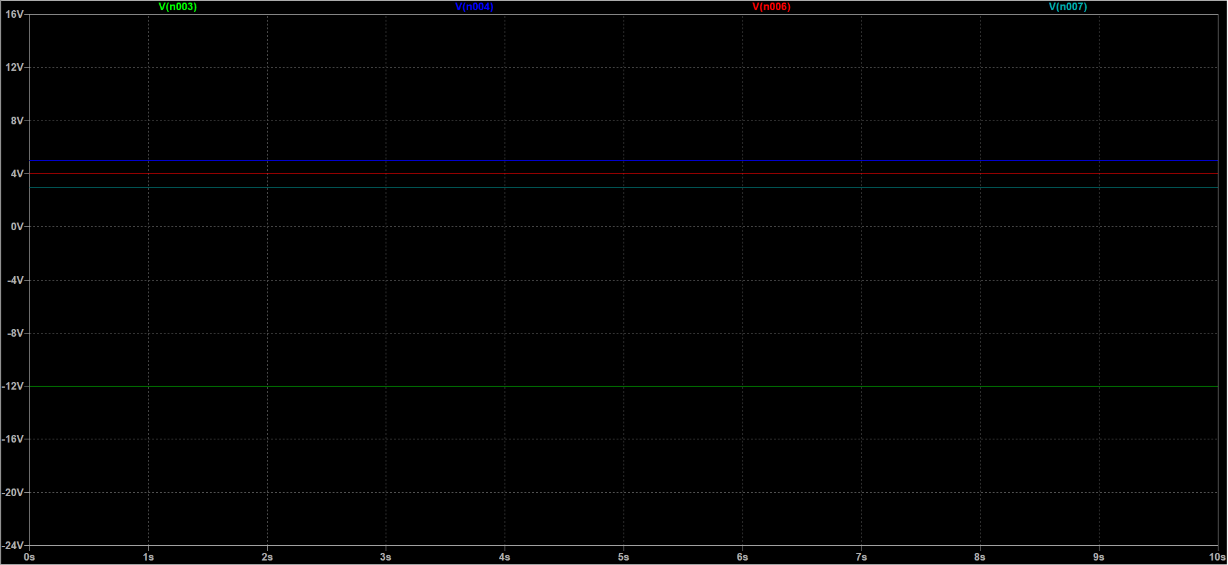

*\*Blue, Red and Paste color lines indicate input*

*\*Green line indicates output*

**Graph 8.1:** Input and Output waveform of Summing amplifier

**Circuit Diagram (Subtractor amplifier):** Circuit used to study Subtractor amplifier is shown in the

following figure:

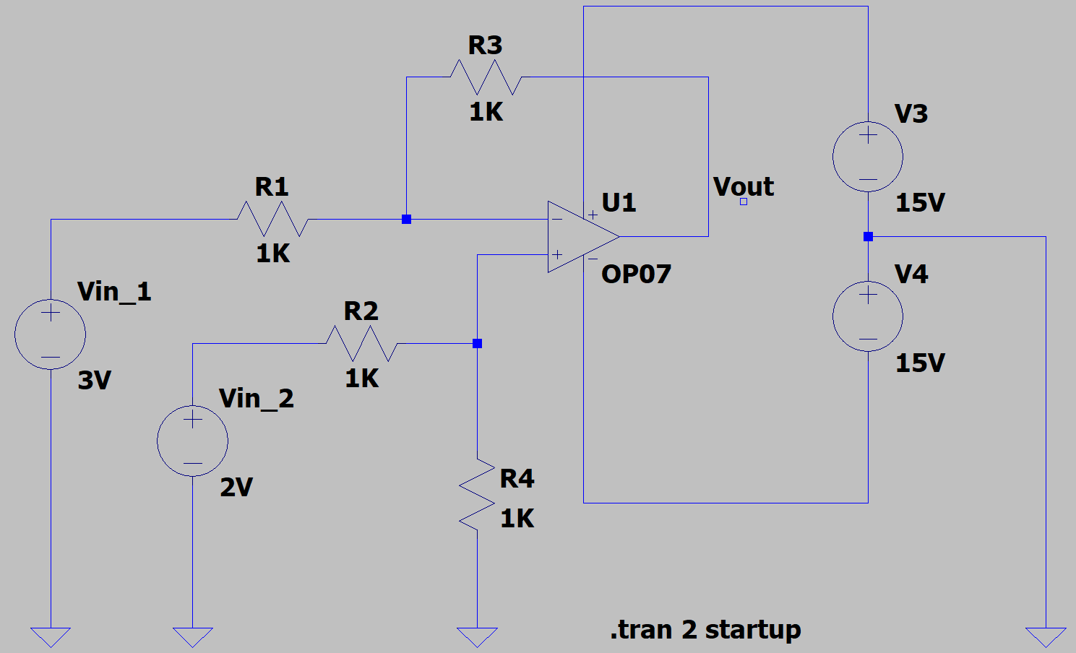

**Figure 8.2:** A Subtractor amplifier using 741 Op-amp

**Graph (Subtractor amplifier):**

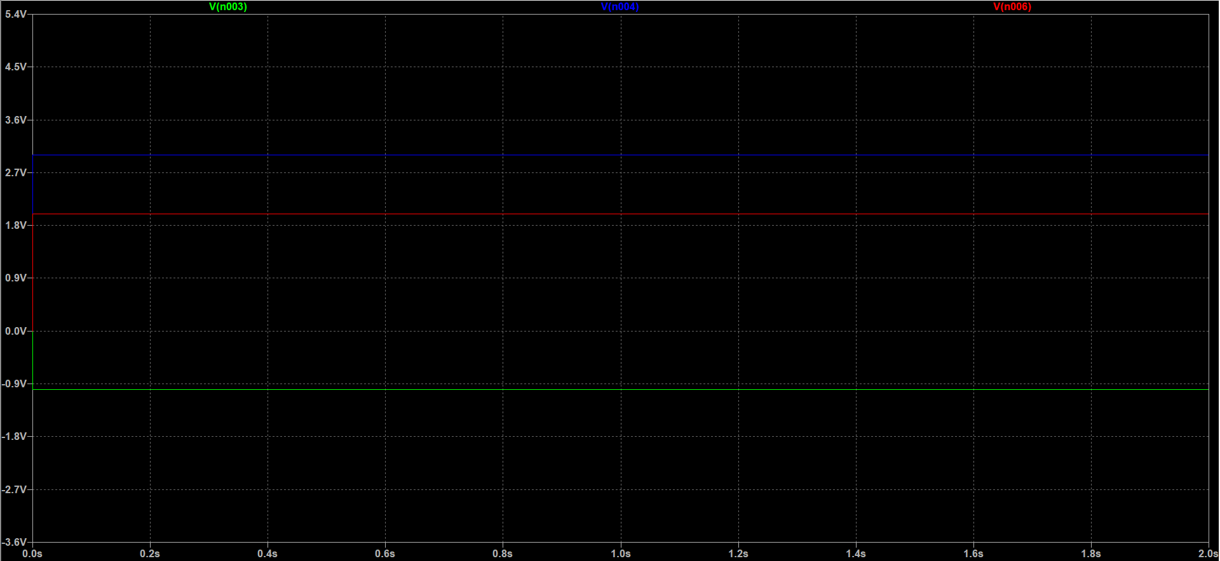

*\*Blue and Red color lines indicate input*

*\*Green line indicates output*

**Graph 8.2:** Input and Output waveform of Subtractor amplifier

***Experiment No:******09***

**Experiment Name:** To design and verify the characteristics of 741 op-am Integrator circuit for different inputs.

**Objective:** To get familiarized with and to observe the characteristics of Integrator circuit for different inputs.

**Components:**

1. DC power supply
2. Digital Multimeter (DMM)
3. Resistor (3 pcs)
4. Capacitor
5. IC — 741 Op-amp
6. Breadboard

**Circuit Diagram:** Circuit used to study Integrator circuit is shown in the following figure:

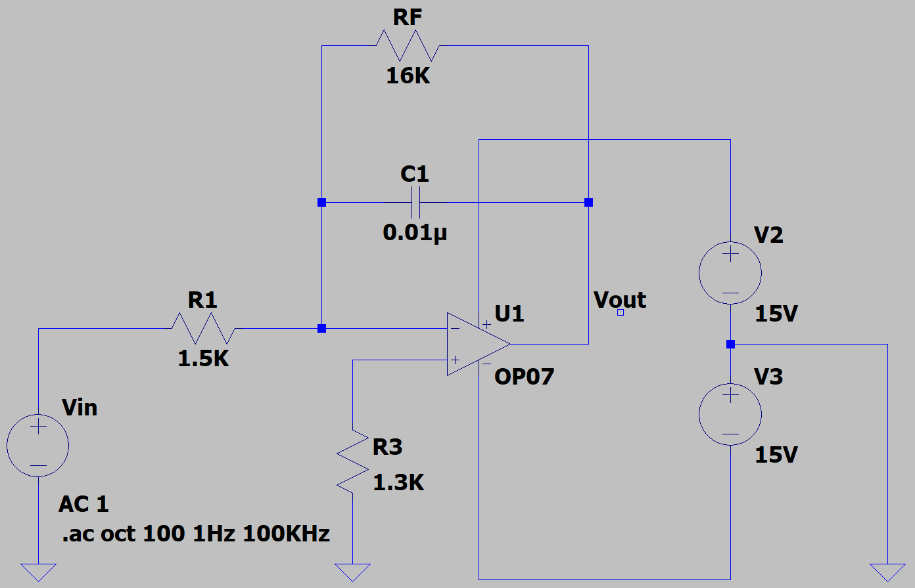

**Figure 9.1:** An Integrator circuit using 741 Op-amp

**Graph:**

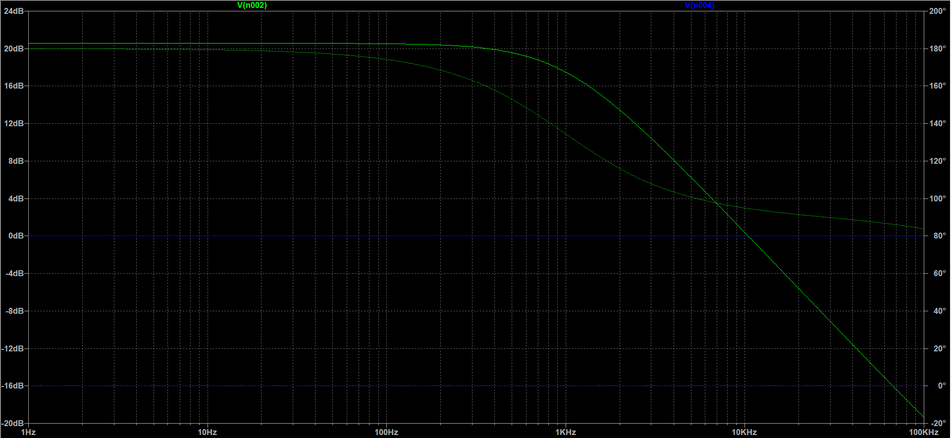

*\*Blue lines indicate input*

*\*Green lines indicate output*

**Graph 9.1:** Input and Output waveform of Integrator circuit

***Experiment No:******10***

**Experiment Name:** To design and verify the characteristics of 741 op-am Differentiator circuit for different inputs.

**Objective:** To get familiarized with and to observe the characteristics of Differentiator circuit for different inputs.

**Components:**

1. DC power supply
2. Digital Multimeter (DMM)
3. Resistor (3 pcs)
4. Capacitor (2 pcs)
5. IC — 741 Op-amp
6. Breadboard

**Circuit Diagram:** Circuit used to study Differentiator circuit is shown in the following figure:

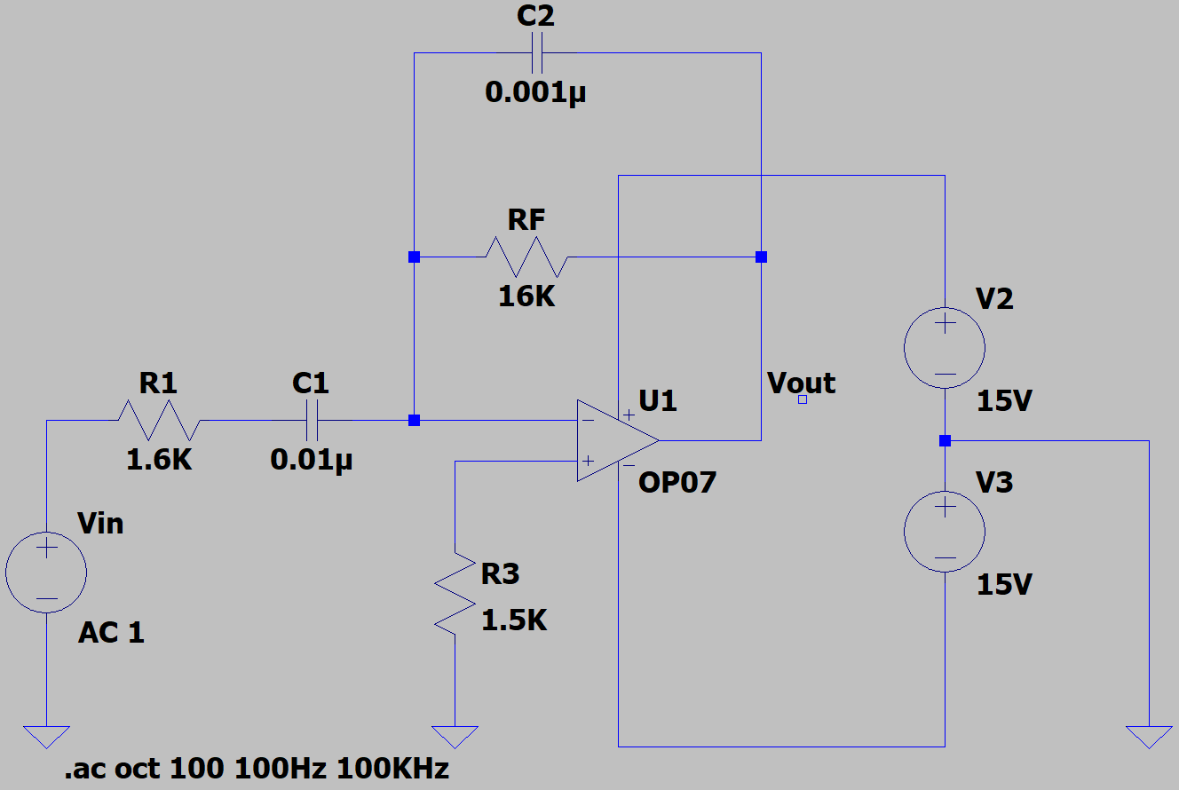

**Figure 10.1:** A Differentiator circuit using 741 Op-amp

**Graph:**

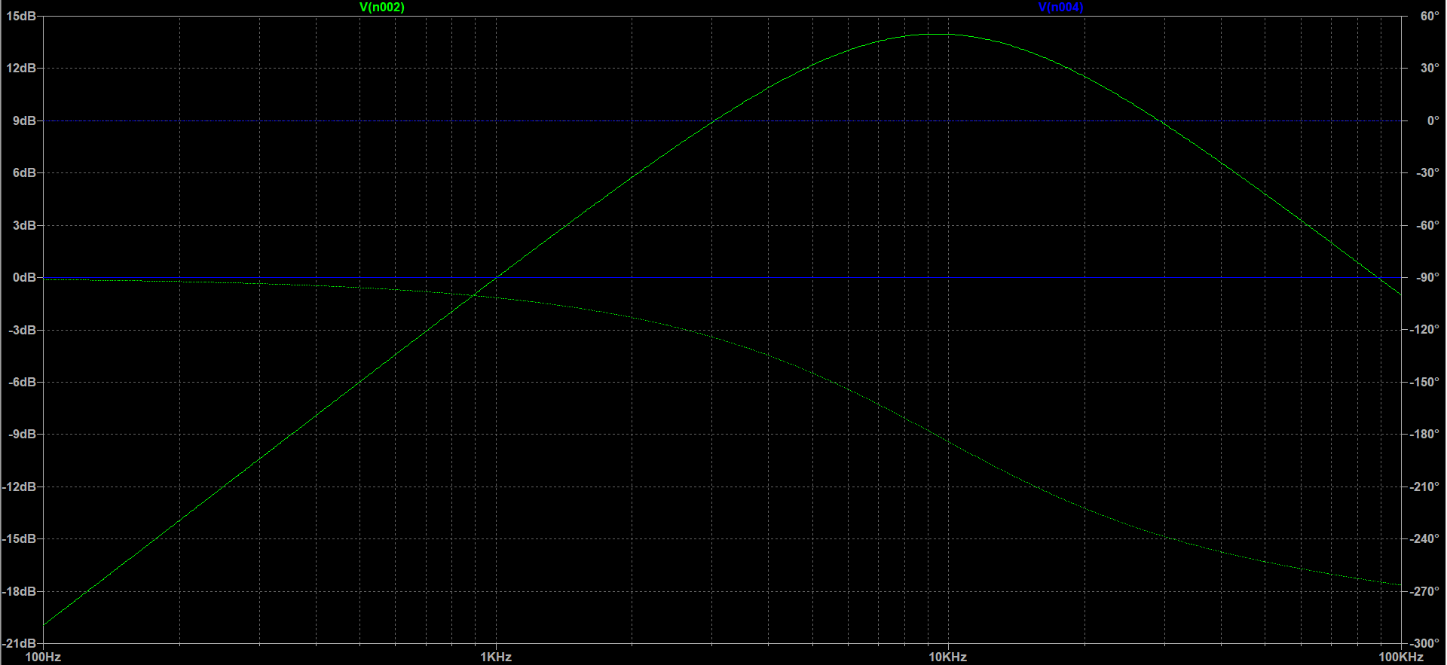

*\*Blue lines indicate input*

*\*Green lines indicate output*

**Graph 10.1:** Input and Output waveform of Differentiator circuit